Treasury Confirmation Process (TCP)

Purpose of the document
The Treasury Confirmation Process Document outlines any Federal Agency (Agency) Treasury Confirmation Process

“This document has been prepared by ETASC BPM & RPA CoE for consumption by partners within the bank in support of their Robotics Process Automation efforts. If the baseline templates need to be altered to suit your program’s needs, the changes have to be carefully vetted by business, technology and ETASC CoE. All suggestions on enhancements to this template should be directed to DG RPA-Team.”

Document Name: | Treasury Confirmation Process (TCP)
Project Name: | Treasury Confirmation

Table of Contents

1.0 Introduction 3
Objectives 3
Process Key Contacts 3
2.0 Process Overview 4
Treasury Confirmation and Reconciliation Window 4
Treasury Confirmation Inquiry 4
Prerequisites for Recording and Confirming Department of Treasury Payments 5
Recording and Confirming Department of Treasury Payments 5
Treasury Confirmation Process Map 7
Treasury Confirmation Process Steps 7
Check Range Examples 8
Business Exceptions Handling 11
Applications Used in the Process 11
Additional Process Documentation 12

Introduction
The Treasury Confirmation Process Document outlines any Federal Agency (Agency) entering and confirming the payment process request in Oracle Payables. The agency sends the payment file to Department of Treasury (Treasury) for payment who in return sends back the Treasury Confirmation report to the Agency.

Objectives
N/A

Process Key Contacts
N/A
Role | Name | Contact details | Notes
Process Owner
Process SME
*
*Add other roles to the table as needed.

Process Overview
Department of Treasury payments are recorded and confirmed in the Treasury Confirmation and Reconciliation window. You can find and view confirmed Department of Treasury payments in the Treasury Confirmation Inquiry window.

Treasury Confirmation and Reconciliation Window
You can use the Treasury Confirmation and Reconciliation window to complete these tasks:
- Record Department of Treasury payment information.
- Allow the recording of more than one check range for a payment schedule with a break in check numbers.
- Create general ledger journal entries that reconcile the payment information against existing payments in Payables.
- Allow reversal of confirmed payments if information must be corrected or updated.
- Allow entry of offset information from Department of Treasury for a specific check.
- Correct Department of Treasury document number if agency goes through a Disbursement Office and an error in sequencing occurs.
- Display voided payments.
Below screen displays Treasury Confirmation and Reconciliation window:
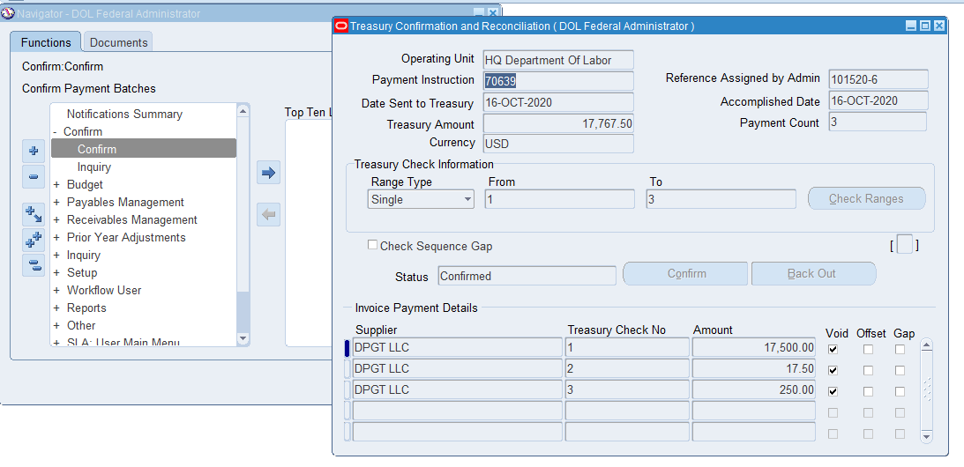

Treasury Confirmation Inquiry
You can use the Treasury Confirmation Inquiry window to view this information:
- Department of Treasury payment information for a given operating unit, vendor, Department of Treasury number, payment date, amount, or payment process request.
- Voided payments
Below screen displays Treasury Confirmation Inquiry window:
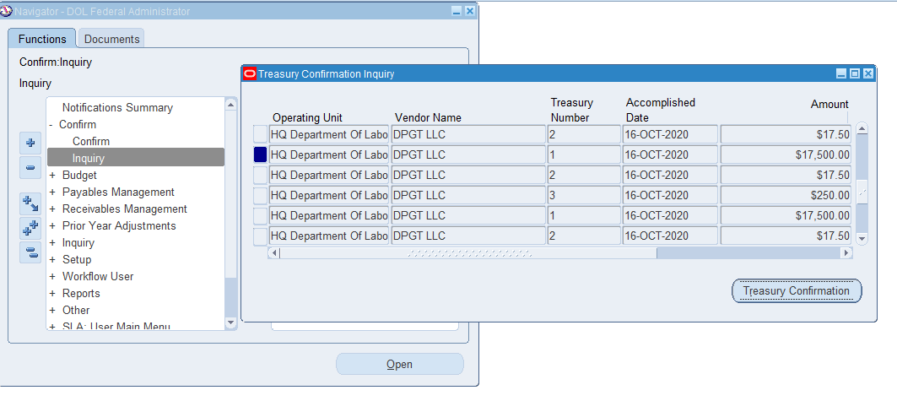

Prerequisites for Recording and Confirming Department of Treasury Payments
Before recording and confirming Treasury payments, you must:
- Complete the payment instructions in Oracle Payments.
- Create accounting entries in Payables for the payments in the payment instruction by running the Create Accounting Process or using the transaction windows.
- The Treasury confirmation processing is performed at the operating unit level. Therefore, payment instructions must only contain payments from a single operating unit. To achieve this, the payment process profile must have the first party organization selected on the payment instruction creation tab for the payment instruction's format.
- Review the Payment Options Cash Clearing account defined on internal Bank Account to ensure they are defined as intended. The Payment Options Cash Clearing account must be defined on the internal Bank Account used by the Payment transaction in order to properly generate the correct accounting for Payment and Treasury Confirmation transactions.
- Review the Assign Check Numbers for Cash Payments checkbox on the Federal Options form for each Reporting Agency to ensure that confirmation of cash payments is configured as intended and, if needed, check numbers to the confirmation transaction

Recording and Confirming Department of Treasury Payments
To record and confirm Department of Treasury payment information, navigate to the Treasury Confirmation and Reconciliation window as follows: Federal Administrator->Confirm->Confirm
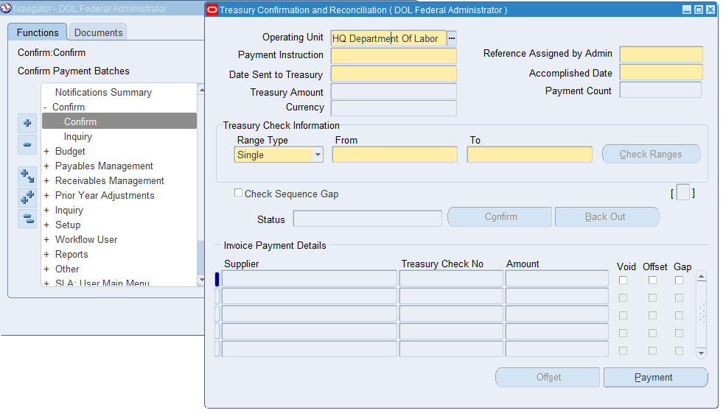
The above screen shot and below table describes selected fields on the Treasury Confirmation and Reconciliation window.
Field Name | Description
Operating Unit | Operating unit of the record.  Note: The list of values include operating units assigned to the MO: Security profile.
Payment Instruction | Payment Instruction
Reference Assigned by Admin | User defined payment instruction name
Date Sent to Treasury | Date payment batch sent to treasury; defaults to payment date in payables
Accomplished Date | Department of Treasury document date; cannot be before the Date sent to Treasury
Range Type | Range type values; includes single or multiple. Default value is single.
From | Beginning check sequence number; required if the range type is single; disabled if range type is multiple
To | Ending check sequence; required if range type is single; disabled if range type is multiple
Check Ranges | Opens check ranges window; disabled if range type is single
Check Sequence Gap | Selected when the range type is set to multiple or when a payment in the batch has an offset record with a corrected treasury check no.
Treasury Check No | Department of treasury check number
Amount | Document amount
Void | Indicates that payment is voided  Note: When a payment is voided in payables, the void check box is selected in the treasury confirmation and reconciliation window.
Offset | Indicates payment has offset
Gap | Indicates payment has a document number sequence gap

Treasury Confirmation Process Map
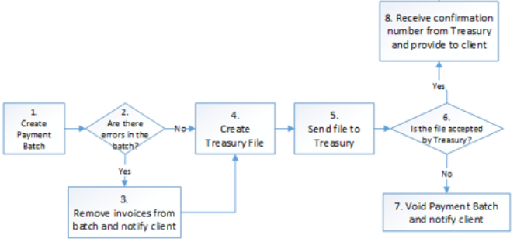

Treasury Confirmation Process Steps

Step | Short Description of Key Process Steps
1 | The agency enters and confirms the payment process request in Oracle Payables.
2 | The agency sends the payment file to Treasury for payment.
3 | Treasury sends back the Agency Confirmation report.
4 | The agency navigates to the Treasury Confirmation and Reconciliation window and enters the Accomplish Date, Amount, and the Treasury Check Information.  If there is only one check range, the agency selects Single as the Range Type. The From and To fields are then required. If there are multiple check ranges, the agency selects Multiple as the Range Type and the agency enters at least two ranges in the Check Ranges window.
5 | If an offset occurs, the agency clicks Offset to enter Offset information from Treasury before confirming the payment.
6 | The agency clicks Confirm in the Treasury Confirmation and Reconciliation window.

Check Range Examples
Below 3 examples explain how the Payables Check Numbers and Treasury Check Numbers are assigned:

Example 1: The Agency Confirmation Report contains an offset.
In this scenario, the offset payment check number is outside of the check range provided by Treasury, and the remaining check numbers are not resequenced.
The payment process request has 8 payments. The payment process request has payment numbers 2202 to 2209. The payment range assigned by Treasury for this payment file is 7 - 14. An offset occurs. Treasury number 74 is assigned to the fifth payment or the original Treasury number 11. This example could be entered in these ways.

A.
Perform these steps:
- Enter Single as the Range Type.
- Enter 7 in the From field and 14 in the To field.
- Place the cursor on the fifth payment, Treasury Check No. 11, in the Invoice Payment Details region.
- Click Offset.
- Enter the Corrected Treasury Check No. as 74.
Gap is now selected for this record in the Invoice Payment Details region and Check Sequence Gap is selected.

B.
- In the Treasury Confirmation and Reconciliation window, click Check Ranges.
- Enter sequences as described in the following table:
Range Sequence | From | To
1 | 7 | 10
2 | 74 | 74
3 | 12 | 14
In both A and B, the Treasury check numbers would be assigned as described in the following table:
Treasury Check Number | Payables Check Number
7 | 2202
8 | 2203
9 | 2204
10 | 2205
74 | 2206
12 | 2207
13 | 2208
14 | 2209

Example 2: The agency Confirmation report contains an offset.
In this scenario, the offset check number is outside of the check range provided by Treasury, and the remaining check numbers are resequenced.
The payment process request has eight payments. The payment process request has payment numbers 2202 to 2209. The payment range assigned by Treasury for this payment file is 7 - 10 for the first four payments. The fifth payment is assigned treasury number 74, and the last three payments are assigned the range 11 - 13. This should be entered as:
Complete the following steps:
- Enter Multiple as the Range Type.
- Click Check Ranges.
- Enter sequences as described in the following table:
Range Sequence | From | To
1 | 7 | 10
2 | 74 | 74
3 | 11 | 13
- The Treasury check numbers would be assigned as described in the following table below:
Treasury Check Number | Payables Check Number
7 | 2202
8 | 2203
9 | 2204
10 | 2205
74 | 2206
11 | 2207
12 | 2208
13 | 2209

Example 3: Multiple check ranges have overlapping ranges.
You cannot use the same Treasury Check number twice for the same payment process request. You will receive an error if these Treasury Check number were entered in the Check Ranges window as described in the following table:
Range Sequence | From | To
1 | 7 | 10
2 | 74 | 77
3 | 75 | 90
Note: This example would result in an error because Range 2 and Range 3 both contain Treasury check numbers 75 through 77.

Business Exceptions Handling
This section provides the possible exceptions
# | Exception name | Step # | Parameters | Action to be taken
 | Backing Out Confirmed Department of Treasury Payments |  |  | Click Back Out on the Treasury Confirmation and Reconciliation window if you make a mistake when entering data. For example, you enter an incorrect Accomplished Date. All journal entries created by the confirmation are reversed.
 | Voiding Confirmed Payments |  |  | To reverse the confirmation entries for payments voided in Oracle Payables after the payment was Treasury Confirmed, use the Submit Request window and select Disbursements in Transit Voided Checks.
 | Offsetting Payments |  |  | To offset a payment before confirmation, navigate to the Treasury Confirmation and Reconciliation window. The following table describes selected fields on the Treasury Confirmation Offset window.  Field Name Description  Vendor Name Derived from treasury confirmation and reconciliation window  Original Treasury Check No. Derived from treasury confirmation and reconciliation window  Corrected Treasury Check No. Corrected department of treasury check number  Offset Party Name Offset source  Original Payment Amount Derived from treasury confirmation and reconciliation window  Net Payment Amount Displayed if offset amount is entered; calculated value derived from original payment amount less offset amount  Void Indicates payment is voided

Applications Used in the Process
N/A
# | Application name & version | System  Language | Login Module | Interface | Environment/  Access method | Comments
1
2
3
*Add more rows to the table as needed.

Additional Process Documentation
N/A
Additional Process Documentation

